Liebe Kolleginnen und Kollegen,

im Sommersemester dürfen wir **Joseph Badokufa Bulugu**, M.Ed., von der **St. Augustine University of Tanzania in Mwanza / Tanzania** im Rahmen des Internationalen Gastdozierendenprogramms der UDE an unserer Fakultät begrüßen.

Um mit vielen Kolleg:innen, auch über das Fachgebiet Erwachsenenbildung hinausgehend, ins Gespräch zu kommen, gibt Herr Bulugu am

**Dienstag, den 06.06.2023 (16:30 Uhr s.t.-17:30), Raum S06 S00 A40,**

einen Einblick in seine Arbeits- und Forschungsschwerpunkte zum Thema:

**“ADULT EDUCATION IN TANZANIA: its development and contribution to the enhancement of adult learner’s employability through service-learning at the St. Augustine University of Tanzania (SAUT)”.**

This lecture debunks the development of Adult Education with a focus on the context of higher education institutions in Tanzania. I will refer to the SAUT Service-Learning initiative, as an educational strategy for enhancing meaningful learning among university students while serving within and beyond the university. Through service-learning, adult learners acquire knowledge, attitude and more importantly, skills that increase their employability and thus add value to them as persons and as professionals. The success narrative of Adult Education progress in Tanzania could be verified in many ways. However, this lecture focuses on how the Service-Learning initiative has consistently contributed to the enhancement of adult learners’ employability in and through higher education institutions.

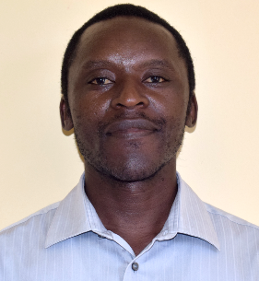

Mr. Joseph Badokufa BULUGU is a faculty member at St. Augustine University of Tanzania (SAUT) [www.saut.ac.tz](http://www.saut.ac.tz) in the Department of Education Foundations. As a researcher, an educator, and a global citizenry mentor to young adults, he actualizes his scholarship in philosophies of education, educational management and administration, and pedagogy through lecturing, publication, and outreach engagements. Through Service-Learning initiatives, Badokufa inspires and empowers university and high school students to initiate mutually beneficial activities that enrich learning and transform local communities with a global-local approach. Badokufa is also a PhD candidate in the Faculty of Educational Sciences, at the Chair of Adult Education, at the University of Duisburg-Essen.

**Wir möchten alle Interessierten zum Vortrag und Austausch herzlich einladen.**

**Die Veranstaltung findet in Präsenz statt.**

**Zwecks Planungen bitten wir bei Teilnahmeinteresse um eine kurze E-Mail an** [**silke.schreiber-barsch@uni-due.de**](mailto:silke.schreiber-barsch@uni-due.de)**.**

Mit den besten Grüßen vom Fachgebiet Erwachsenenbildung,

Silke Schreiber-Barsch